US–MENA PRIVATE SECTOR DIALOGUE (PSD) 2026

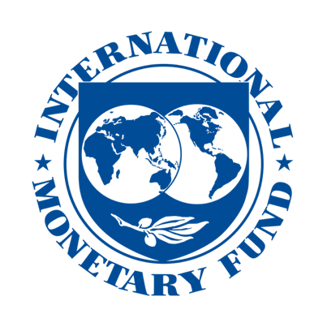
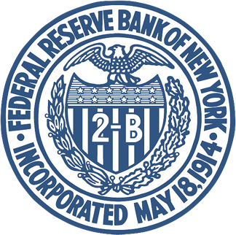



------------------------------------------------------------------------------------------------------------------
With the Participation of the U.S. Department of Treasury
------------------------------------------------------------------------------------------------------------------

Celebrating 20th Anniversary
US–MENA PRIVATE SECTOR DIALOGUE (PSD) 2026

Where U.S. regulatory expectations meet MENA banking leadership.
A high-trust, senior-level banking dialogue focused on correspondent banking access, AML/CFT, sanctions, financial crime, digital assets, AI-enabled compliance, and cross-border payment integrity.

30th October 2026 JP Morgan HQ, New York, USA

Agenda and Strategic Discussion Themes

Strengthening US–MENA Financial Integrity, Correspondent Banking Access & Cross-Border Compliance
US–MENA PSD 2026 brings together senior banking leaders, regulators, compliance decision-makers, correspondent banking executives and financial crime specialists to address the critical regulatory and market issues shaping MENA banks’ access to the global financial system.

1. The New U.S. AML/CFT Compliance Landscape
Treasury, FinCEN & Governance Expectations
Key discussion points:
- Shift from technical compliance to outcome-based AML/CFT programs
- FinCEN expectations for risk-based, measurable and effective controls
- Board-level oversight and senior management accountability
- Enterprise-wide compliance governance and institutional resilience
- Integrating U.S. AML/CFT priorities into bank risk assessments
- Beneficial ownership, complex structures and hidden control risks
- Legal defensibility of AML/CFT and sanctions compliance programs
Why it matters:
Banks must prove not only that controls exist, but that they are effective, risk-based and defensible.

2. Safeguarding Correspondent Banking Access
Transparency, KYCC & Cross-Border Visibility
Key discussion points:
- Preserving correspondent banking relationships under higher scrutiny
- U.S. correspondent bank expectations on transparency and governance
- KYCC and payment-chain visibility
- Understanding underlying counterparties and transaction ecosystems
- Managing de-risking pressures while preserving financial access
- Cash economies, informal channels, MSBs and shadow banking risks
Why it matters:
Correspondent banking access remains a strategic lifeline for MENA banks, trade flows and financial connectivity.

3. Syria, Iraq & High-Risk Jurisdictions
Practical Risk Management Without Political Positioning
Key discussion points:
- Managing exposure to complex jurisdictions through risk-based controls
- Humanitarian channels and permitted financial flows
- Reconstruction-related transactions and compliance safeguards
- Syria’s evolving trade, compliance and financial landscape
- Export controls, dual-use goods and restricted party screening
- Readiness gaps in compliance programs across high-risk markets
Why it matters:
Banks need practical frameworks to support permitted activity while managing sanctions, trade and reputational exposure.

Page 2: Emerging Risk Areas

4. Trade, Oil, Shipping & Financial Crime Risk
Commodity Flows, Maritime Exposure & Sanctions Circumvention
Key discussion points:
- Trade-based money laundering and false documentation
- Invoice manipulation, trade mispricing and false origin declarations
- Maritime due diligence and vessel ownership transparency
- Shipping routes, vessel monitoring and sanctions exposure
- Regional maritime disruptions and trade finance implications
- Oil payments, commodity transactions and intermediary risks
- Supply-chain diversion and dual-use goods exposure
Why it matters:
Trade, oil and shipping channels are increasingly used to disguise financial crime, sanctions evasion and illicit flows.

5. Sanctions, Iran-Linked Risks & Regional Escalation
Managing Hidden Exposure in a Volatile Environment
Key discussion points:
- Sanctions compliance in a rapidly changing regional environment
- Emerging sanctions evasion typologies and risk indicators
- Intermediary networks, front companies and alternative payment channels
- Secondary sanctions and indirect exposure
- Risks linked to customers, vessels, insurers, counterparties and trade routes
- OFAC expectations for shipping and safe-passage payments
- Digital assets and sanctions evasion risks
- Corruption, illicit networks and financial integrity exposure
Why it matters:
Sanctions risk is no longer limited to named parties; exposure can emerge through indirect links, trade routes and hidden networks.

6. AI, Digital Finance & Compliance Technology
Building Future-Ready Compliance Controls
Key discussion points:
- Digital assets, stablecoins and evolving AML/CFT expectations
- VASPs and cross-border digital asset transfers
- Cyber-enabled financial crime and sanctions evasion
- Travel Rule compliance and payment transparency
- AI-backed controls for AML/CFT, sanctions and financial crime compliance
- Governance, suitability and oversight of AI-enabled compliance tools
- Banks, fintechs, VASPs and MSBs in the evolving financial ecosystem
Why it matters:
Technology can strengthen compliance, but only when supported by governance, explainability and regulatory confidence.

Closing Brochure Statement
US–MENA PSD 2026 is a high-level, invitation-led dialogue focused on protecting correspondent banking access, strengthening regulatory trust and helping MENA financial institutions navigate the next era of AML/CFT, sanctions, digital finance and cross-border compliance.

